
https://atlas.cid.harvard.edu/

Optimal Industry Development Strategy Using Economic and Product Complexity

France

─
The Economic Complexity Lab - Columbia University
Haoxian Chen, Davepriyan Gunaratnam, Rohan Macherla, Ajit Akole, Shomik Ghose, Alex Wei-Liang Ku, Sannidhya Modi, Xilin Wang, Alexandra Garcia, Kelly Mi, Alex Chung, Margarita Demkina
Optimal Industry Development Strategy for France

0. Executive Summary

In this report, we aim to uncover the economic path France went through during the period from 2013 to 2021. Specifically, we dive into the topic through a macroeconomic overview of France from the perspective of Gross Domestic Product (GDP) and Economic Complexity Index (ECI), which reflect countries’ production capability and production structure, respectively. We find that between 2013 and 2018, France demonstrated a low level of economic growth with an annual GDP growth rate of 0.8%, concurrent with a stagnation in economic complexity as compared with other major economies in Europe. Between 2019 and 2021, France demonstrated a moderate level of economic growth with an average annual GDP growth rate of 3.75%, with a slightly lower economic complexity compared to other major developed European economies.

The mixed progress during the period, we believe, can be partially explained through the analysis of the economic and product complexity structure of France on the industry group level, as well as the improved macro and microeconomic strategies. The product classification system we adopt allows us to measure the realized industry development for various industry groups and to observe that France progressed in developing most of its industries during the period while its developed counterparts and economies around the globe also adopted complex and progressive paths with variable degrees of success.

Based on our analysis of the opportunity gain and sensitivity analysis of major industry groups, France could further its gains by prioritizing Machinery and Construction, and Services and Utilities in 2018. Three years later, in 2021, its focus should shift to the High-complexity Product and Transportation industries, which are also one of the more developed industries at the time. We further note that France has a similar development strategy that indicates a moderate level (compared to other developed countries) of structural optimality on the complexity level, having an adjusted R-square of around 4.1% in 2018 and a much higher score of 7.6% in 2021, demonstrating an improvement in development. Since a significant positive correlation exists between five-year GDP growth between 2013 and 2018 and the structural optimality index of an economy as we define and calculate, France indeed has improved its growth as compared with fast-growing economies both on a regional scale and on a global scale, but has the potential to further its economic gains through industrial structure optimization as suggested in the paper.

The three years following showed a significant improvement in France's economic growth, boosting its position on the global scale. Its GDP recovered to above the pre-pandemic levels, and it saw a significant boost in the ECI, particularly compared to its peer countries. Its current strategy still has the viable potential upside to increase its performance and optimize its structure further.

1. Report Overview

In this report, we aim to uncover the economic path France went through during the period from 2019 to 2021, before and after the COVID pandemic, compared to its performance from 2013 to 2018. Specifically, we dive into the topic through a macroeconomic overview of France from the perspective of Gross Domestic Product (GDP) and Economic Complexity Index (ECI), which reflect countries’ production capability and production structure, respectively. We then analyze the industrial framework and changes of France during the period based on quantitative measures such as the Product Complexity Index (PCI) and Product Family Complexity Index (PfCI), followed by a detailed analysis of how such changes have matched with development strategies as quantitatively measured by opportunity gains on an industry-level. We conclude our report with macro-level results and predictions of France, as deduced from regression models we have established on a global scale, which take into account countries’ stances in their product space.

2. Macroeconomic Results

2.1 GDP Ranking and Changes
As the 7th largest economy in the world by GDP, France has a GDP of 2.7 trillion USD in 2018 and 2.9 trillion USD in 2021, exhibiting an extraordinary level of economic output.

Figure 1a illustrates the time-series GDP results for France and other leading economies (China, Japan, Germany, and the United States) from 2013 to 2018. While other countries displayed an upward trend over the period, France was observed with a mostly stagnant GDP level. France’s annual growth rate of around 0.8% was significantly below the annual growth rate of other leading economies, which had a geometric average growth rate of 2.4% and an arithmetic average growth rate of 2.6% during the same period. The stagnated economic growth in France, we believe, can be reflected through consistent ECI and PCI, and can be further explained by a suboptimal set of production strategies France adopted during the period, which we will expand at the later stage of the report.

Figure 1b shows the GDP levels for France and its peer countries (Germany, United Kingdom, Italy, and the United States) from 2019 to 2021. Similar to the other countries, France displayed a small dip in GDP from 2019 to 2020 due to the pandemic, with all GDPs rebounding in 2021. Over these three years, France’s average annual GDP growth rate (3.8%) is in the middle, as it is greater than Italy’s rate (2.2%) and roughly equal to the United States’s rate (3.7%), but less than Germany and the United Kingdom’s rates (4.2% and 5.2%, respectively). It is notable that the GDP trend of France and its European peers are very similar, with a slight upward trend in 2021 and a drop in 2020.
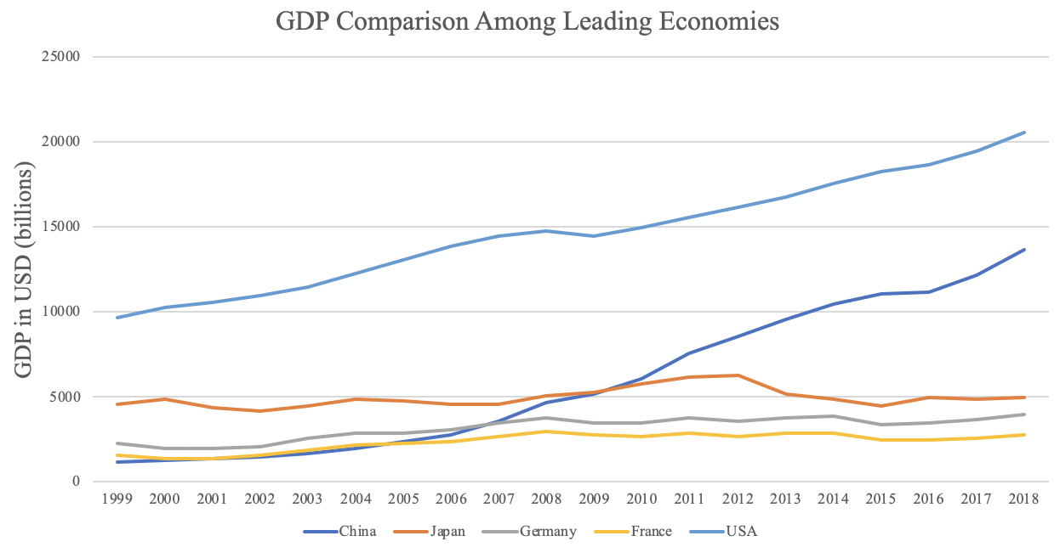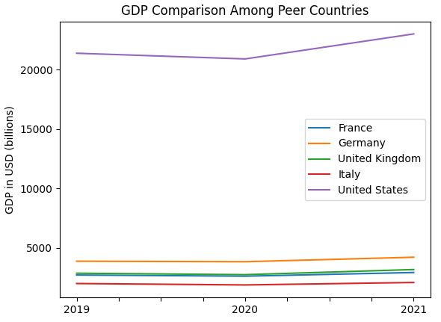
Figures 1a and 1b. GDP Comparison Among Peer Countries (left: 1999-2018; right: 2019-2021)

2.2 ECI Ranking and Changes
The Economic Complexity Index (ECI), as defined by Ricardo Hausmann and Cesar Hidalgo in 2009 to explain the knowledge accumulated in a country's population, is illustrated in Figures 2a and 2b. While France exhibits a stable but flat curve in terms of its production capability from 2014 to 2018, it witnessed a sharp decline from 2013 to 2014 that was not present in other countries. Overall, France lagged behind its peers in terms of both ECI and GDP growth during the period.

The comparable countries maintain a small change in ECI level between 2019 and 2020, with a sharp drop between 2020 and 2021. France exhibits a sudden large decrease in production capability in 2021, partially attributed to diminished production capacities during the pandemic. France has seen a 59% decrease in its ECI, which is worse than the USA's (25% decrease) but better than Germany's (94% decrease).
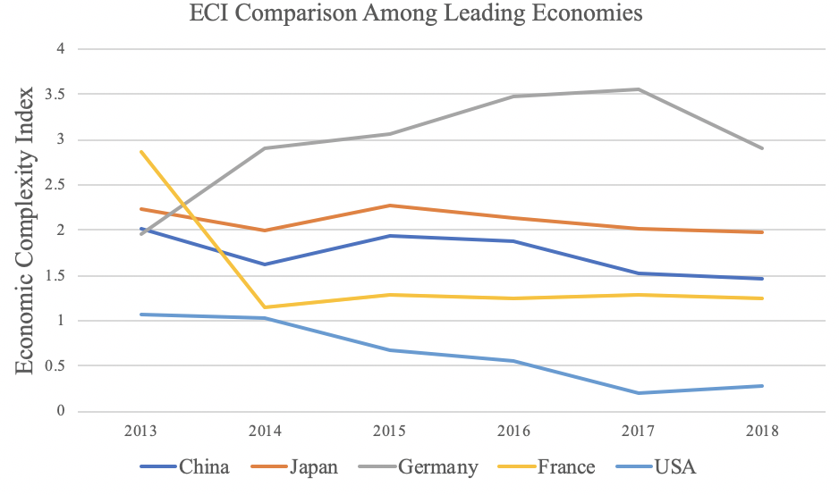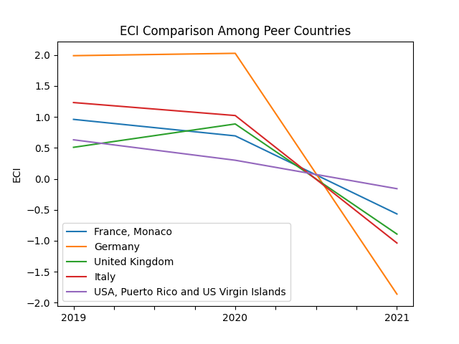
Figures 2a and 2b. ECI Comparison Among Peer Countries (left: 2013-2018; right: 2019-2021)

Figures 3a and 3b offer a further comparison of GDP Growth and ECI over the time span from 2013 to 2021 for France. Similar to the GDP drop and further increase from 2013 to 2018, the GDP growth during the period from 2019 to 2021 is accompanied by a similarly volatile increase in ECI. The results show that the economic growth experienced by France during the period from 2013 to 2018 is only partially consistent with the predictions by ECI and that France made weak progress towards effectively developing a competitive product space that helps to accumulate complicated knowledge and technology. For the period 2019 to 2021, the ECI followed GDP trends, which can be interpreted as advancements in production. In order to provide a more concrete answer to why this has happened, we will dive into an analysis of France’s production structure and its product space designs in the next few sections.

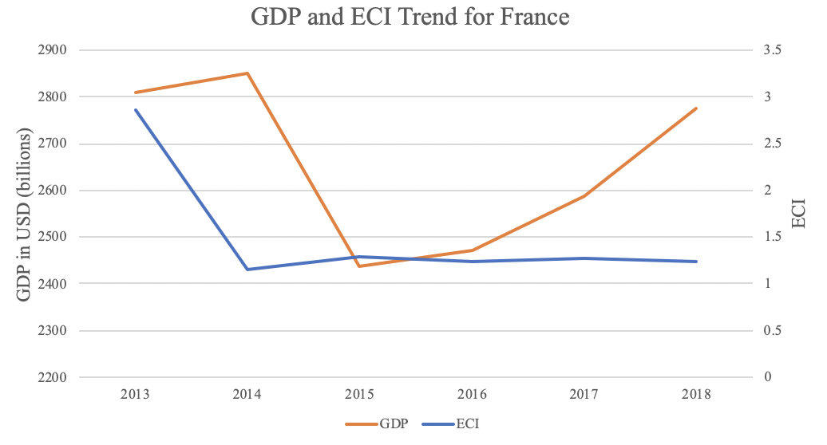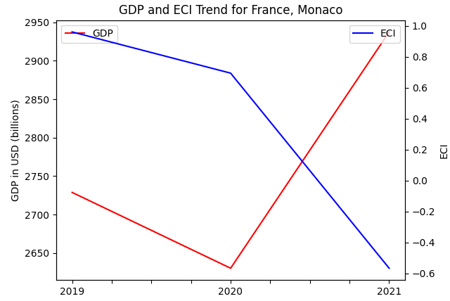Figures 3a and 3b. GDP Growth and ECI for France (left: 2013-2018; right: 2019-2021)

3. Production Analysis

3.1 Product Categorization
Our main data source in this research is the UN Comtrade Website (https://comtrade.un.org), which provides us with valuable information on countries’ export values on an annual basis, including highly specific export data for more than 5000 categories of products. In order to have a holistic vision of the product space of a country, however, a level of categorization is required. Products in our data source are labeled from 010000-999999, with the first two digits representing a general category to which the product belongs. Based on the 99 categories extracted from the label, we further group the products into the 18 most widely-accepted industries, as summarized in Table 1.

Note that the High-complexity Products industry group is not a distinct industry but rather an aggregated industry that encompasses the most complicated products from the most technologically-advanced industries (as measured by PCI). This industry serves as an indicator for us to quantitatively evaluate how well a country has performed in developing cutting-edge technologies and closing its technological gap with advanced economies, which has become a topic of wide concern today. Indeed, when we rank the 18 categories based on PfCI (an equivalent concept of PCI as calculated based on the 18 categorized product groups), the High-complexity Products industry has the highest PfCI among all industry groups.

Category | Description
Animals and By-products | All kinds of meat, livestock and related by-products
Vegetables, Fruits and Plants | All kinds of plants, edible vegetables and fruits
Food and Preparations | Edible preparations, raw cooking materials and appliances
Clothing and Accessories | All kinds of fabrics, filament, clothing and accessories
Textiles | All kinds of textile articles and related products
Wood Products | Book, paper and other elementary products related to wood
Metals | Mining of all sorts of raw Metals
Refined and Processed Stones | Refined or processed stone products such as pearl and ceramics
Energy Drilling and Mining | Mining industry for energy, minerals, stone materials, etc.
Daily Instruments | Basic daily instruments such as sport requisites, timing and measuring tools
Raw Manufacturing | Basic products made from plastic, rubber, leather, etc.
Chemical Manufacturing | Advanced chemical products and pharmaceutical products
Chemicals | Raw chemical materials and by-products
Machinery and Construction | Machinery and mechanical appliances, including electrical equipment
Transportation | Vehicles and locomotives including aircraft, ship, railway, etc.
Weapons | Explosives, arms and ammunition
Services and Utilities | Financial, business, legal, communication, travel Services and Utilities, etc.
High-complexity Products | Agglomeration of advanced products with highest PCIs

Table 1: Categorization of Products

We further observe a positive correlation between the GDP and the export of High-complexity Products. A higher adjusted R-square exists between GDP and High-complexity Products exports, indicating that more successful economics, as measured by GDP, tend to be those that are capable of producing and exporting High-complexity Products as we define them. Tables 2a and 2b show the OLS results in a universe of 107 and 21 typical countries respectively.

 | High-complexity Products | Food and Preparations | Animals and By-products
Adj. R-squared | 0.075 | 0.006 | 0.002
F-statistic | 9.556 | 1.638 | 1.175
No. Observations | 107 | 107 | 107

Table 2a. OLS Regression Results of GDP against Percentage Volume of Exports

 | High-complexity Products | Food and Preparations | Animals and By-products
Adj. R-squared | 0.149 | 0.003 | -0.012
F-statistic | 4.510 | 1.059 | 0.7542
No. Observations | 21 | 21 | 21

Table 2b. OLS Regression Results of GDP against Volume of Percentage Exports

3.2 Realized Industry Development
Based on the aforementioned product categorization, we aim to capture France's realized industry production strategy between 2013 and 2021 on a complexity level. In Hausmann and Hidalgo (2009), distance is defined to be a measure of how far a country is from a certain product, not in its product space. We extend this concept to all product groups and quantify how technically equipped a country is to develop the corresponding product groups. In other words, the shorter the distance between a country and a product group, the more capable a country is of developing products within that group. Defining this net distance change as the Realized Industry Development (RID), our export data allow us to calculate and compare the RID of France and the 18 product groups in 2021 and 2018 through the difference, where a positive RID indicates a shortening of the distance (i.e., advancement of the industry), and a negative RID indicates the reverse. It is notable that the number of industries with positive RID has increased from 0 in 2018 to 13 in 2021. As shown in Table 3, during the period from 2019 to 2021, France has focused on developing Services and Utilities, Precious Stones, and High-complexity Products in particular.

Category | RID (2021) | RID (2018)
Daily Instruments | -0.017 | -0.241
Chemicals | -0.012 | -0.102
Weapons | 0.004 | -0.114
Wood Products | 0.003 | -0.111
Transportation | -0.005 | -0.178
Machinery and Construction | 0.021 | -0.324
Metals | 0.008 | -0.136
Raw Manufacturing | -0.023 | -0.080
Services and Utilities | 0.074 | -0.114
Clothing and Accessories | 0.010 | -0.113
Chemical Manufacturing | 0.018 | -0.095
Food and Preparations | 0.012 | -0.134
Textile | -0.052 | -0.147
High-complexity Products | 0.041 | -0.129
Vegetables, Fruits and Plants | 0.018 | -0.120
Animals and By-products | 0.012 | -0.118
Energy Drilling and Mining | 0.028 | -0.082
Precious Stones | 0.042 | -0.086

Table 3. Realized Industry Development (RID) of France

3.3 Regional and Global Comparison
Tables 4a-4b below summarize how the production strategy adopted by France compares with selected leading economies in the world across different years, as measured in RID. Between 2018 and 2021, France focused more on product groups with higher complexity, and as a result, those high-complexity groups achieved the highest RID. In 2021, compared to the United States, France gave a similar level of attention to more advanced product groups such as High-complexity Products, Services and Utilities, and Energy Drilling & Mining. Whereas France and Germany exhibited similar development levels for High-complexity products and Food and Preparations, France surged ahead of Germany in Services and Utilities and Precious Stones in 2021.

Ranking | France | United States | Germany
1 | High-complexity Products | Services and Utilities | High-complexity Products
2 | Chemical Manufacturing | Weapons | Transportation
3 | Daily Instruments | Raw Manufacturing | Wood Products
4 | Animals and By-products | Precious Stones | Metals
5 | Food and Preparations | Animals and By-products | Food and Preparations

Table 4a. RID Comparison across Leading Economies (2018)

Ranking | France | United States | Germany
1 | Services and Utilities | Precious Stones | Daily Instruments
2 | Precious Stones | High-complexity Products | Transportation
3 | High-complexity Products | Services and Utilities | Chemicals
4 | Energy Drilling & Mining | Energy Drilling & Mining | Chemical Manufacturing
5 | Machinery & Construction | Wood Products | Clothing and Accessories

Table 4b. RID Comparison across Leading Economies (2021)

Tables 4c-4d further examine France's development strategy against those of emerging economies on a global scale. Reasonably, emerging economies such as China, South Korea, and Singapore have devoted the majority of their efforts to intermediate industry groups, showing moderate shifts in strategies over the course of three years.

Ranking | China | South Korea | Singapore
1 | High-complexity Products | Transportation | Transportation
2 | Transportation | Textile | High-complexity Products
3 | Machinery and Construction | High-complexity Products | Precious Stones
4 | Energy Drilling and Mining | Chemical Manufacturing | Daily Instruments
5 | Daily Instruments | Machinery and Construction | Services and Utilities

Table 4c. RID Comparison across Emerging Economies (2018)

Ranking | China | South Korea | Singapore
1 | Chemicals | Chemicals | Weapons
2 | Daily Instruments | Daily Instruments | Energy Drilling and Mining
3 | Transportation | Transportation | Transportation
4 | Raw Manufacturing | Textile | Machinery and Construction
5 | Weapons | Raw Manufacturing | High-complexity Products

Table 4d. RID Comparison across Emerging Economies (2021)

4. Product Space Design

4.1 Suggested Development Vector
As outlined above, distance gives us an idea of how far each new product is from a country’s current mix of exports. As defined in Hausmann and Hidalgo (2009), distance is “the weighted proportion of products connected to goods p that country c is not exporting, i.e., MCP = 0.” Based on this definition, the distance between a country and any product that the country is currently exporting (i.e., the country is a significant exporter of the product as compared to the global average) is zero. Similarly, opportunity gain quantifies the contribution of a new product in terms of opening up the doors to more and more complex products. Intuitively, a product that a country is currently exporting (i.e., MCP = 1) has an opportunity gain of zero. An unreasonable investment in a certain product p would lead to a relative decrement in the export of more profitable products and therefore lead to a negative opportunity gain of product p. The opportunity gain is not the only estimator of a country’s level of economic development. However, among countries with comparable economic strength, those having higher ECI, or in other words, more reasonable economic structures are often in better shape.

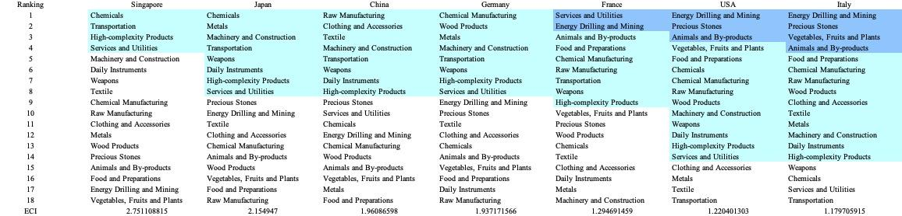

Table 5a. Opportunity Gain Ranking on a Comparable Scale (2013)

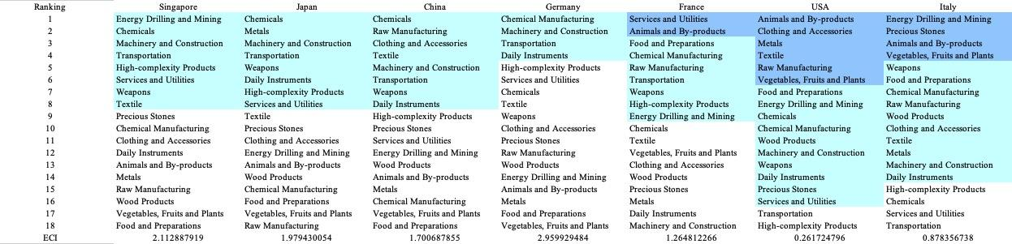

Table 5b. Opportunity Gain Ranking on a Comparable Scale (2018)

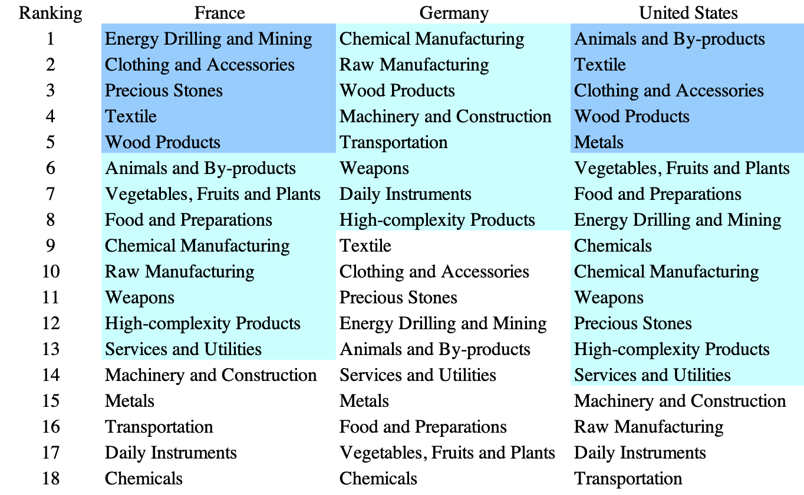

Table 5c. Opportunity Gain Ranking on a Comparable Scale (2021)

We define the ranking of opportunity gain for a country c, as the Suggested Development Vector (SDV) of c. Tables 5a-5c summarize how the SDV of France compares with a selected group of comparable and leading economies in the world, with the industry groups ranked in decreasing order of significance. We focus on SDV results for 2018 because they give the most accurate snapshot of complexity for global comparison in the absence of the irregular effects of the COVID-19 pandemic observed in 2021.

Dark blue indicates positive opportunity gains, light blue indicates zero opportunity gains, and white indicates negative opportunity gains. The result shows that leading countries barely have any industries with positive opportunity gain. In other words, those countries are already in the most stable and efficient economic structure. Without the necessity of economic transition, those countries merely need to maintain a steady and balanced economic development. In contrast, developing countries have nearly half of the industries with positive opportunity gain and share common interests in industrial manufacturing and high-tech industries. It can be concluded that France, a developed country, shares some characteristics of developing countries, with a balanced economic structure that leans towards high-end industries.

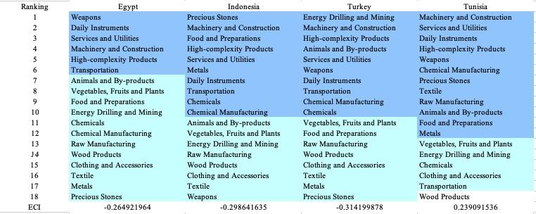

Table 6. SDV of Other Sample Countries (2018)

4.2 Budgeted Industry Development Strategy and Interpretation
The optimal budgeted industry development strategy aims to solve the most efficient allocations under the budgeted constraint of different situations of heuristic total export growth. In order to obtain such an allocation portfolio, we formulate an optimization problem as the following:



where k(x) is the second largest eigenvector of $M_{CC'}$ after adding $x$ to the original export vector, C is the country that we are interested in, P is the product space, B is the heuristic budget.

If we can solve this problem, then we can know what the largest ECI to which a country can improve. Accordingly, the optimal solution $x*$ that we obtain here is exactly our optimal allocation. However, the biggest problem is that the objective function is not convex. Therefore, we cannot apply the classical tools for convex optimization to this problem. In order to solve this problem, our idea is to use a greedy algorithm. The way that we apply the greedy algorithm is that firstly we separate the total budget into k equal parts, and then for the first equal part we try to search for the product that can optimize our objective function by iterating through each $p∈P$. After we find the optimal product p for this equal part, we add the amount back to the export value of this product p and update the ECI for this country. If we observe that ECI does not change after iterating all the products, then we can add up one more equal part to invest. Until we find there is an ECI increment, we add the amount now to that product. The equal rest parts can be done in the same way.

By definition, a greedy algorithm is a kind of local search algorithm that is possible to run into a local minimum. Therefore, for local search algorithms, one typical way to keep it away from the local minimum is to enhance the vision of the algorithm by looking more steps forward. In our setting, whenever we obtain an increment of ECI, we mark down the required amount of export growth. Simultaneously, we continue searching for the next ECI increment point, compare the ratios of these two possibilities and pick the largest one. The ratio is defined as the following:

where ${ECI}_{p}$ is just the ECI of the country after adding some amount of export increment to product $p$, which is exactly the amount that is able to make ECI change. Also, we can express it in the way of $||$$x_{p}-x_{0}$${||}_{1}$.

In this way, we can obtain a further sighted greedy algorithm. Also, the number of parts that we would like to separate the budget into also matters. In order to solve this problem, we added a stabilizer on top of the enhanced greedy algorithm by running the algorithm for different numbers of parts and selecting the portfolio with the largest ECI increment and most complex economic structure.

Besides, it is quite common that there is a surplus in the budget. To deal with the surplus, we just add it to the product which needs the least amount of dollars to make $M_{cp}$ = 1 (i.e., the smallest amount of required export increase).

Economic Panel
As stated above, the enhanced greedy algorithm is developed mainly for solving the optimal allocation strategy. In order to visualize this allocation, an economic panel is created, consisting of a pie chart, a line chart, and a table. First, a pie chart is used to show the percentage of each product in the optimal portfolio. The number located in the center of the circle denotes the heuristic growth of total export, which is also our budget. Each category in the chart has a determined percentage of the allocated budget. The lines below the pie charts show how the ECI changes during the search process of the greedy algorithm. Even though sometimes an increase in the export by 15% or 20% does not seem reasonable to developed countries, it can also give a sense of how a country should develop in the long term. In the end, the graph serves as a numerical explanation for the pie charts.

Interpretation
For the purpose of a clear explanation of the line charts, we label all the products in Table 7. Please refer to this table when trying to understand the investment trajectories in the line charts.

Label | Product Names
1 | Animal and By-products
2 | Vegetables, Fruits and Plants
3 | Food and Preparations
4 | Energy Drilling and Mining
5 | Chemicals
6 | Chemical Manufacturing
7 | Raw Manufacturing
8 | Wood Products
9 | Clothing and Accessories
10 | Textile
11 | Metals
12 | Machinery and Construction
13 | Transportation
14 | Weapons
15 | Daily Instruments
16 | Precious Stones
17 | High-complexity Products
18 | Services and Utilities
Table 7. Products Labeling

Figures 4a-4c show an economic panel for France in 2013, 2018, and 2021. We can see that for different percentages of heuristic total export growth, the ECIs of France actually have different increments. While the ECI growth of France in 2013 heavily relied on Wood Products, the optimal resource allocation shifted drastically to Energy Drilling and Mining in 2021.

For 2013, in the case of 5 percent export growth, Wood Products was one of the main components at 36.4% allocation. With a budget of 10 percent export growth, Wood Products accounted for most of the portfolio at 68.2%. It appears that increasing the percentage allocation of Wood Products at each increment yields the optimal ECI growth result. A more detailed numerical representation of the portfolio is shown in Table 8a.
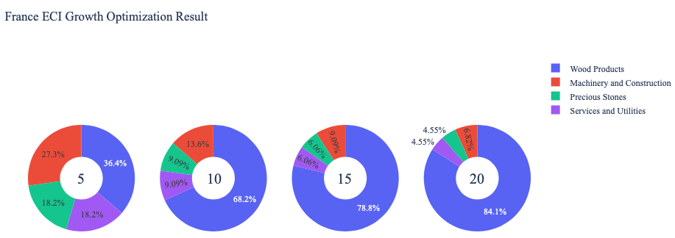

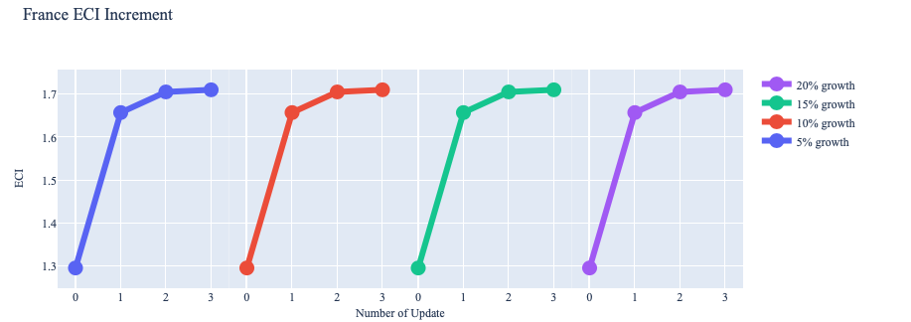

Figure 4a. Greedy-Based ECI Improvement Results of France with Different Budgets (2013)

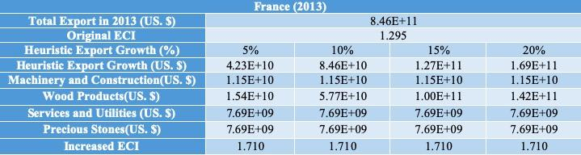

Table 8a. Portfolio of France (2013)

For further suggestions on France’s development in the future, we also offer the optimization result based on its export data in 2018. Below is the economic panel for France in 2018. Similar to 2013, a budget of 10 percent export growth made Wood Products account for the majority of the portfolio at 72.6%. However, unlike before where the percentage of Wood Products in the portfolio grows at each increment, it actually decreases for the budget of 15 percent export growth. A more detailed numerical representation of the portfolio is shown in Table 8b.

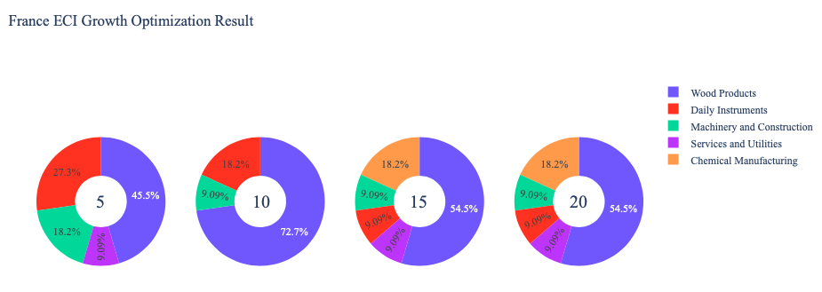
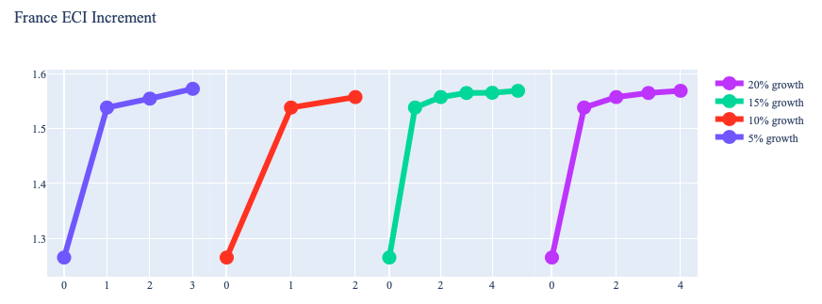

Figure 4b. Greedy-Based ECI Improvement Results of France with Different Budgets (2018)

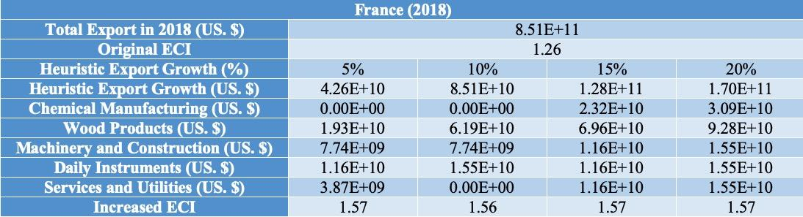

Table 8b. Portfolio of France (2018)

To compare with the performance in 2013 and 2018, we also re-examine suggested strategies for 2021. For 2021, a 5 percent increase in export would emphasize Precious Stones, while a 10, 15, and 20 percent export growth would correspond to Machinery and Construction, Machinery and Construction (again), and Energy Drilling and Mining, respectively. These strategies go in line with the suggested trajectories based on ECI. A more detailed numerical representation of the portfolio for Country is shown in Table 8c.

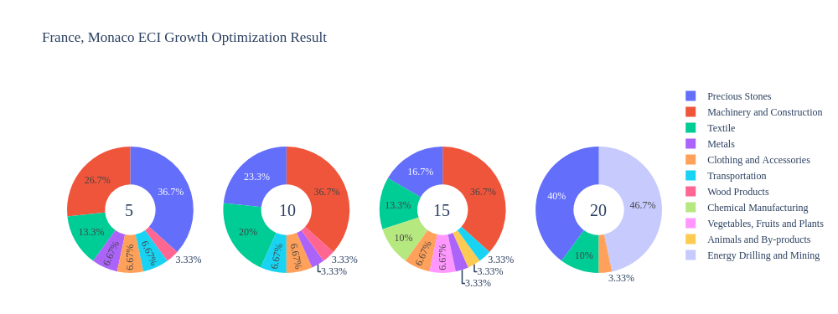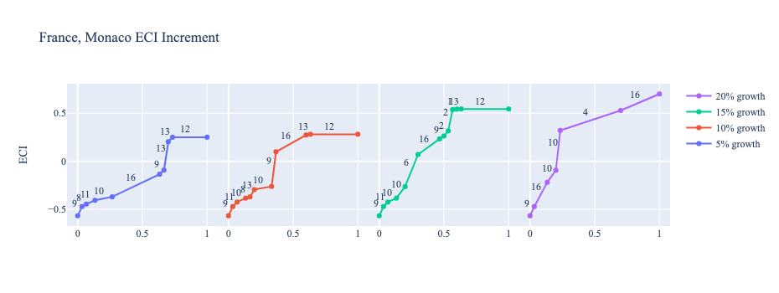
Figure 4c. Greedy-Based ECI Improvement Results of France with Different Budgets (2021)

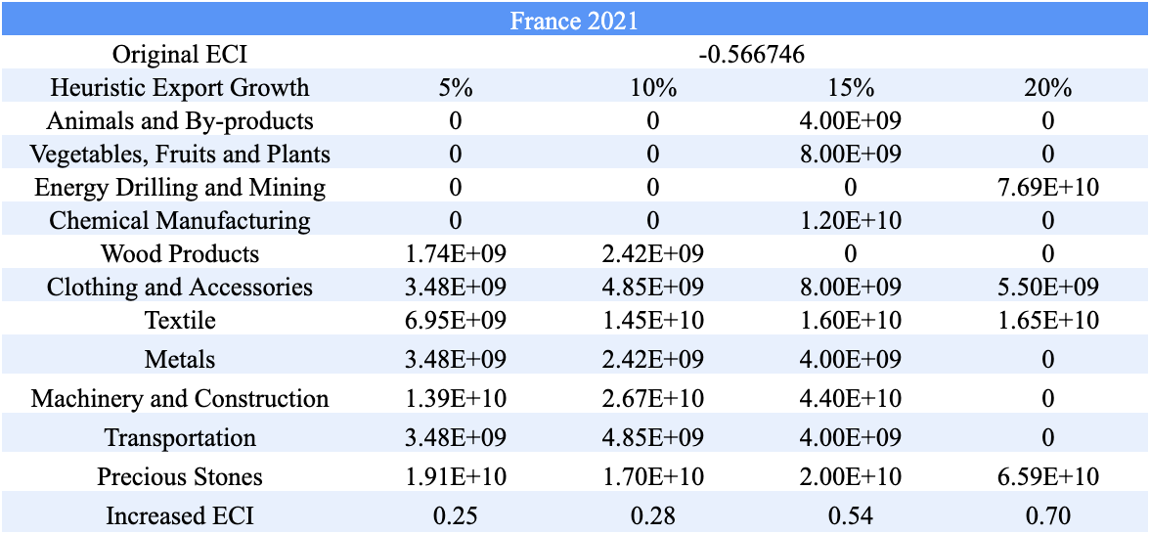

Table 8c. Portfolio of France (2021)

4.3 Sensitivity Analysis and Contingency Strategy
In the following section, our broad aim is to understand how sensitive France is to changes in export in various industries. While the Economic Complexity Index has been shown to contain valuable information about the economic strength/capacity of a country, little has been said as to the stability of the measure itself. We seek to uncover the main drivers of stability under a country's ECI score and better understand longer-term projections for ECI growth. Additionally, gaining an intuition on the industries that are bolstering an economy and the industries that offer the greatest return per unit of investment is best done through visualization of industry-specific sensitivity. To this end, we have developed two categories of sensitivity analysis.
ECI Sensitivity Graph
First, in order to assess the effect particular industries have on each respective country, we developed ECI Sensitivity graphs (Figure 5). We use the shocking methodology to increment or decrement an industry’s export level by a certain percentage and recalculate the ECI, all else being equal. While freezing the export dynamics of the rest of the world and enacting an instantaneous shock in export for a particular industry and country may not reflect real-life dynamics, what it does offer us is an understanding of a country’s level of dependency on an industry in the context of ECI. The shocking is done in small percentage increments in order to smooth out the resulting curve. Additionally, a recurring theme one will see is that for most industries, a breaking point occurs where the ECI either jumps upwards or downwards, creating a hockey stick shape rather than a linear trend. While the inflection point may not be accurate in the context of real life, comparing the various inflection points across industries can give us valuable insight.

Figure 5. Sample ECI Sensitivity Graph (2018)
The graphs are formulated as follows. There are six ECI Sensitivity graphs, two for each of the following years: 2021, 2018, and 2013. The first chart, Incremental ECI Sensitivity, shows positive shocks in which export numbers are shocked upwards per industry. The X-axis is in terms of percentage shock per current dollar value of export. The Y-axis is the recalculated ECI level post-shocking. The second chart, Decremental ECI Sensitivity, follows the same format except the X-axis represents negative shock. In other words, exports for each industry are decremented, and the ECI is accordingly recomputed.
Contingency Plan
The Contingency Plan aims to present a set of solutions with respect to upheavals in different industries. Instead of compensating for the declining production directly, the best strategy is to develop those incipiently profitable industries. In this manner, we can derive a contingency strategy for countries to deal with possible abrupt declines of crucial industries. In some cases, the SDV remains unchanged even when a zero-opportunity-gain industry declines to 20% in terms of export. We can then conclude the industry is not indispensable to the country. As a clarification, the three consecutive N/As mean that the country doesn’t even need to respond to a collapse in the industry. Countries tend to have distinct solutions to the ups and downs of the same industry. To create the contingency strategy table, we decrease the export level for each industry in the country’s current production space by 60% respectively. The three highest-ranking industries in the new SDV are then returned.

Product Names | 0 | 1 | 2
Animal and By-products | Services and Utilities | Daily Instruments | Weapons
Vegetables, Fruits and Plants | Services and Utilities | Daily Instruments | Weapons
Food and Preparations | Services and Utilities | Daily Instruments | Weapons
Energy Drilling and Mining | Services and Utilities | Daily Instruments | Weapons
Chemicals | Services and Utilities | Daily Instruments | Weapons
Chemical Manufacturing | Services and Utilities | Daily Instruments | Weapons
Raw Manufacturing | Services and Utilities | Daily Instruments | Weapons
Wood Products | Services and Utilities | Daily Instruments | Weapons
Clothing and Accessories | Services and Utilities | Daily Instruments | Weapons
Textile | Services and Utilities | Daily Instruments | Weapons
Metals | Services and Utilities | Daily Instruments | Weapons
Machinery and Constructions | Services and Utilities | Daily Instruments | Weapons
Transportation | Services and Utilities | Raw Manufacturing | Daily Instruments
Weapons | Services and Utilities | Daily Instruments | Transportation
Daily Instruments | Services and Utilities | Weapons | Transportation
Precious Stones | Services and Utilities | Daily Instruments | Weapons
Daily Instruments | Services and Utilities | Daily Instruments | Weapons
Services and Utilities | Daily Instruments | Weapons | Transportation

Table 10. Sample Contingency Strategy (2019)

SDV Sensitivity
Contingency Plan
The Contingency Plan aims to present a set of solutions with respect to upheavals in different industries. Instead of compensating for the declining production directly, the best strategy is to develop those incipiently profitable industries. In this manner, we can derive a contingency strategy for countries to deal with possible abrupt declines of crucial industries. In some cases, the SDV remains unchanged even when a zero-opportunity-gain industry declines to 20% in terms of export. We can then conclude the industry is not indispensable to the country. As a clarification, the three consecutive N/As mean that the country doesn’t even need to respond to a collapse in the industry. Countries tend to have distinct solutions to the ups and downs of the same industry. To create the contingency strategy table, we decrease the export level for each industry in the country’s current production space by 60% respectively. The three highest-ranking industries in the new SDV are then returned.

Product Names | 0 | 1 | 2
Animals and By-products | Services and Utilities | Vegetables, Fruits and Plants | Food and Preparations
Vegetables, Fruits and Plants | Animals and By-products | Chemical Manufacturing | High-complexity Products
Food and Preparations | Energy Drilling and Mining | Food and Preparations | Precious Stones
Energy Drilling and Mining | Energy Drilling and Mining | Precious Stones | Clothing and Accessories
Chemicals | Energy Drilling and Mining | Clothing and Accessories | Precious Stones
Chemical Manufacturing | Energy Drilling and Mining | Precious Stones | Textile
Raw Manufacturing | Energy Drilling and Mining | Precious Stones | Textile
Wood Products | Energy Drilling and Mining | Precious Stones | Clothing and Accessories
Clothing and Accessories | Energy Drilling and Mining | Precious Stones | Clothing and Accessories
Textile | Energy Drilling and Mining | Clothing and Accessories | Precious Stones
Metals | Energy Drilling and Mining | Precious Stones | Textile
Machinery and Construction | Energy Drilling and Mining | Clothing and Accessories | Precious Stones
Transportation | Energy Drilling and Mining | Precious Stones | Textile
Weapons | Energy Drilling and Mining | Weapons | Textile
Daily Instruments | Energy Drilling and Mining | Precious Stones | Clothing and Accessories
Precious Stones | Energy Drilling and Mining | Precious Stones | Clothing and Accessories
High-complexity Products | Energy Drilling and Mining | Precious Stones | Textile
Services and Utilities | Energy Drilling and Mining | Clothing and Accessories | Precious Stones

Table 10. France Contingency Strategy (2021)

4.3 Sensitivity Analysis Results and Interpretation

We examine France's ECI Decremental and Incremental Sensitivity Charts for 2021. An increase in High-complexity Products will lead to the highest change in ECI, followed by Transportation. None of the other industries positively impacted ECI significantly. For the negative shock cases, decreasing the export of Animals and By-products and Vegetables, Fruits and Plants become the most impactful, which corroborates our claim that higher complexity industries result in higher economic complexity. The rest of the industries do not appear to have the same level of sensitivity.

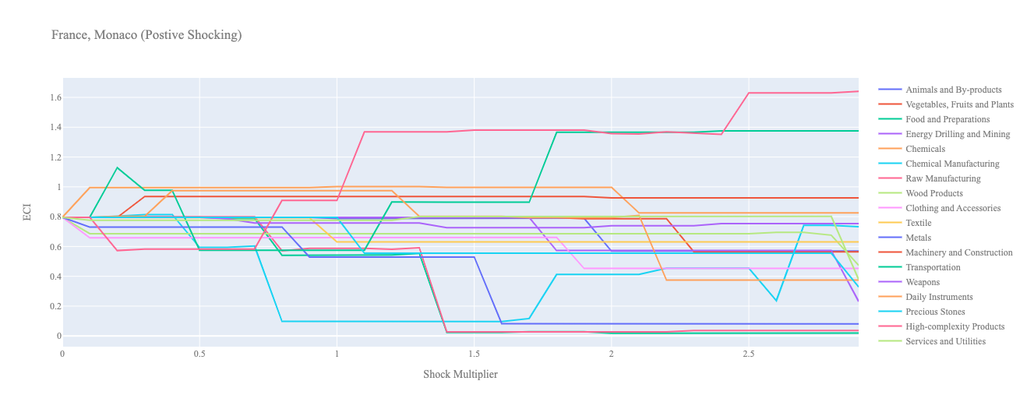
Figure 6a. Incremental ECI Sensitivity for France (2021)
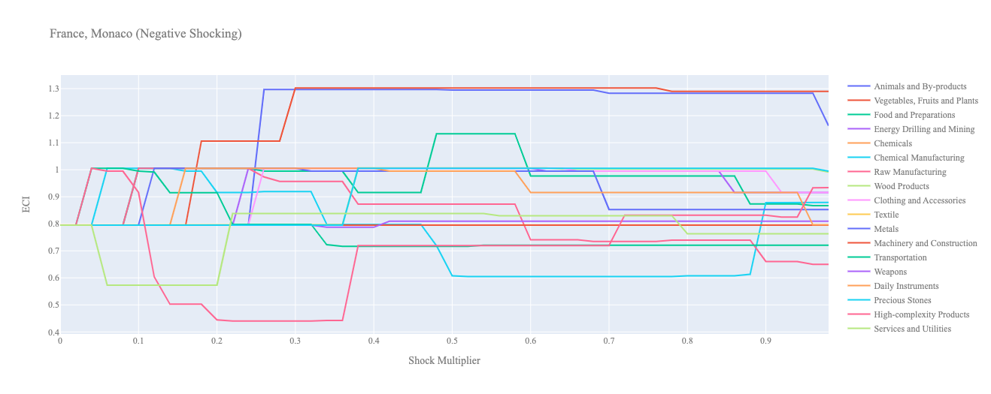
Figure 6b. Decremental ECI Sensitivity for France (2021)

Below is France’s 2018 ECI Sensitivity Charts. Firstly in the positive chart, we notice that small increases in export value in Machinery lead to an increase in ECI. Interestingly though, after a 100% increase, the Machinery Industry forces the ECI level to plummet. Increases in the export of High-complexity Products also lead to ECI expansion. However, almost 150% of positive choking in export is required to experience this gain.

Next, we consider France’s 2018 Negative Shock chart. We can see that France is fairly sensitive to High Complexity Products and Transportation, which is expected from a developed country. It seems that France’s ECI benefits from decreases in the export of lower-complexity products, such as Animals and By-products and Food and Preparation.
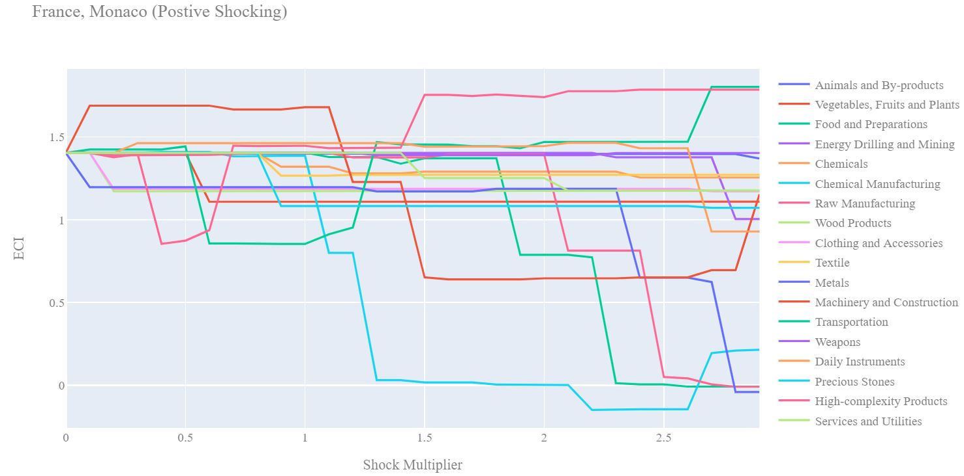

Figure 7a. Incremental ECI Sensitivity for France (2018)

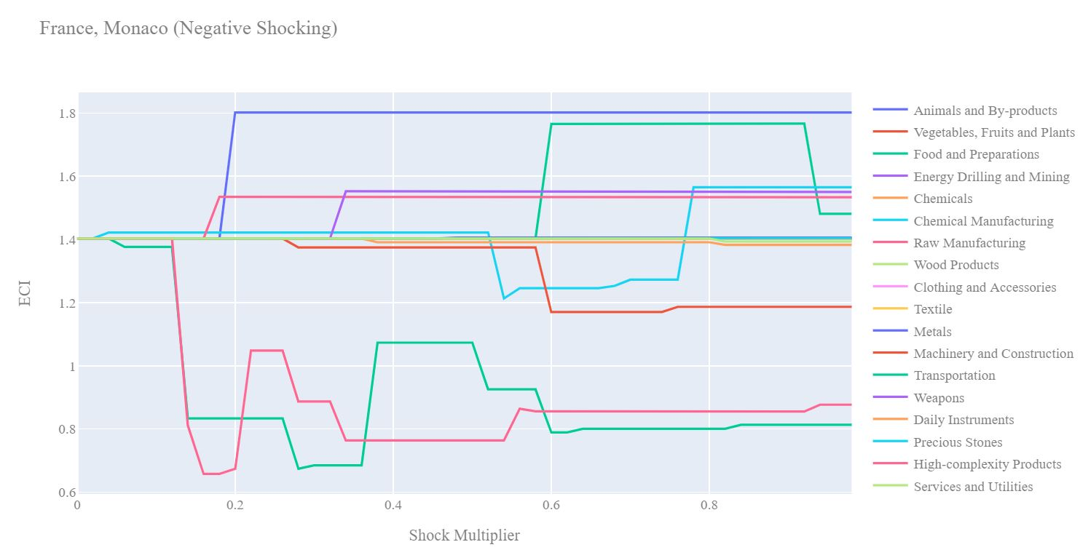

Figure 7b. Decremental ECI Sensitivity for France (2018)

Next we consider the 2013 ECI Sensitivity graphs. We see that in the positive shocking case, the ECI sensitivity profile has not changed significantly over the five-year period. Machinery seems to offer the fastest ECI growth when exports are increased. High Complexity Products offer similar ECI growth however require over 150% increase in export value.

In the 2013 negative shocking case, we see that again France is fairly sensitive to drawbacks in High Complexity Products and Transportation. Overall the 2013 negative shock graph for France is quite similar to the 2018 graph.
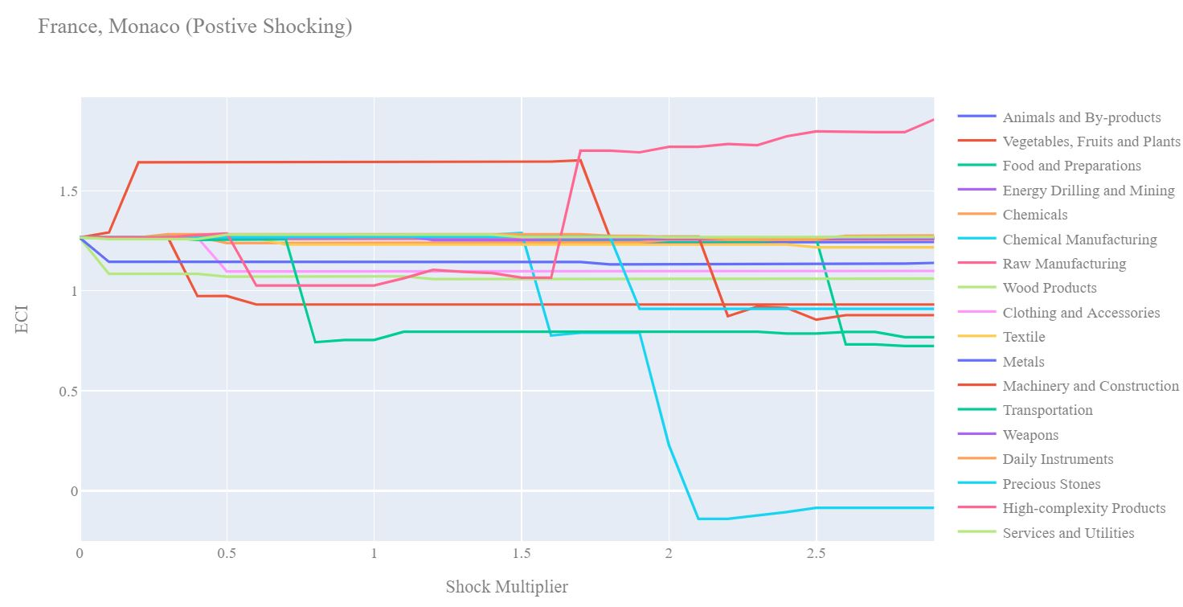

Figure 8a. Incremental ECI Sensitivity for France (2013)

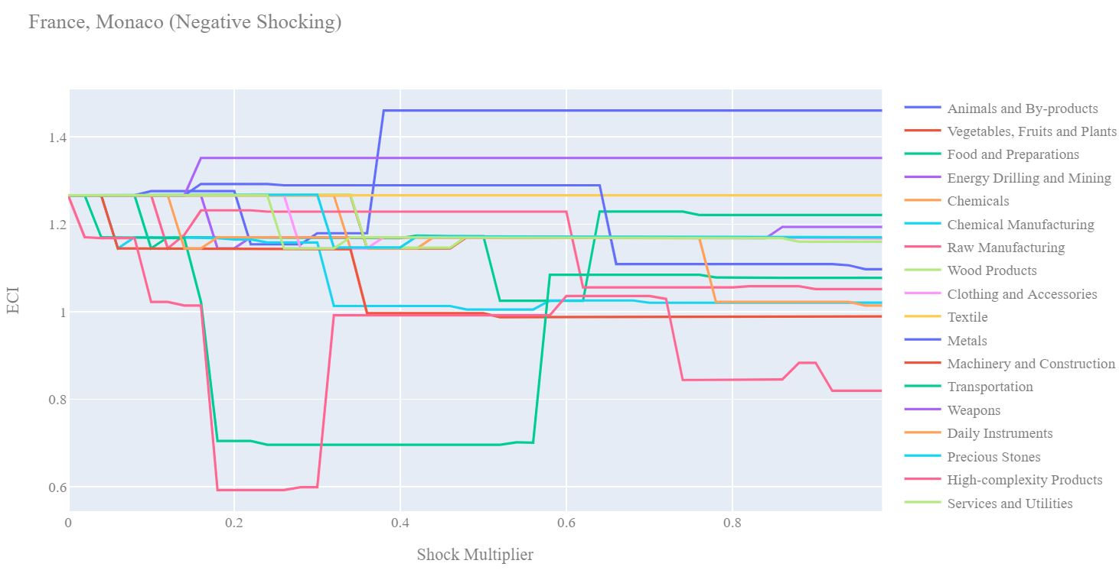

Figure 8b. Decremental ECI Sensitivity for France (2013)

5. Macro-level Predictions

5.1 Structural Optimality Index
ECI sensitivity described in the section before has proven to be a significant factor in deciding the economic outcomes of countries. In order to quantitatively evaluate how effective our development strategies are and how deviations from the suggested developmental path will lead to suboptimal growth results, we define the measure – Structural Optimality Index (SOI) – on a country level as the Adjusted R-Square obtained from regressing the country’s realized industry development over the suggested development strategy. Both strategies are quantified in nature, with the realized development represented by increasing export in every major industry group and the suggested development strategy represented by the opportunity gains of developing the corresponding industry groups as calculated in previous sections. The adjusted R-square from the regression thus provides us with a quantified measure of how the development path adopted by the country has fitted with/differed from calculations on a complexity level.

After obtaining this measure for all countries in our database, we further regress countries’ five-year economic growth, which is defined as the percent increase in GDP (USD), over their SOI. Figure 9 illustrates the regression output, which shows a strong positive correlation between countries’ SOI and their five-year GDP growth, significant at the 1% level and achieving an adjusted R² of 4.5%. In other words, the more a country develops as suggested by calculations on a complexity level, the better economic outcomes it achieves.

Table 14: OLS Regression Results
Dep. Variable: GDP | F-Statistic: 5.963
R²: 0.054 | Prob (F-Stat): 0.0163
Adj R²: 0.045 | No. Observations: 106

Figure 9. Regression of Five-Year GDP Growth over SOI (2013-2018)

5.2 SOI of France and Its Implications
France ranks 52nd place among all countries in terms of SOI and has a 5-year SOI growth rate of 16.47% from 2013 to 2018, which is consistent with the regression result in Figure 6. This is in direct contrast to emerging economies such as Turkey, where there is a high SOI of around 21.8% and a corresponding GDP growth of 36.7% from 2013 to 2018, making it one of the fastest-developing economies during the period. In sum, France’s slower economic progress from 2013 to 2018 can be at least partially explained by a mismatched development strategy that demonstrates a considerable level of deviations from our suggested developmental path. In specific, France invested heavily in the transportation industry, while it should have focused more on industry groups such as Services and Utilities.
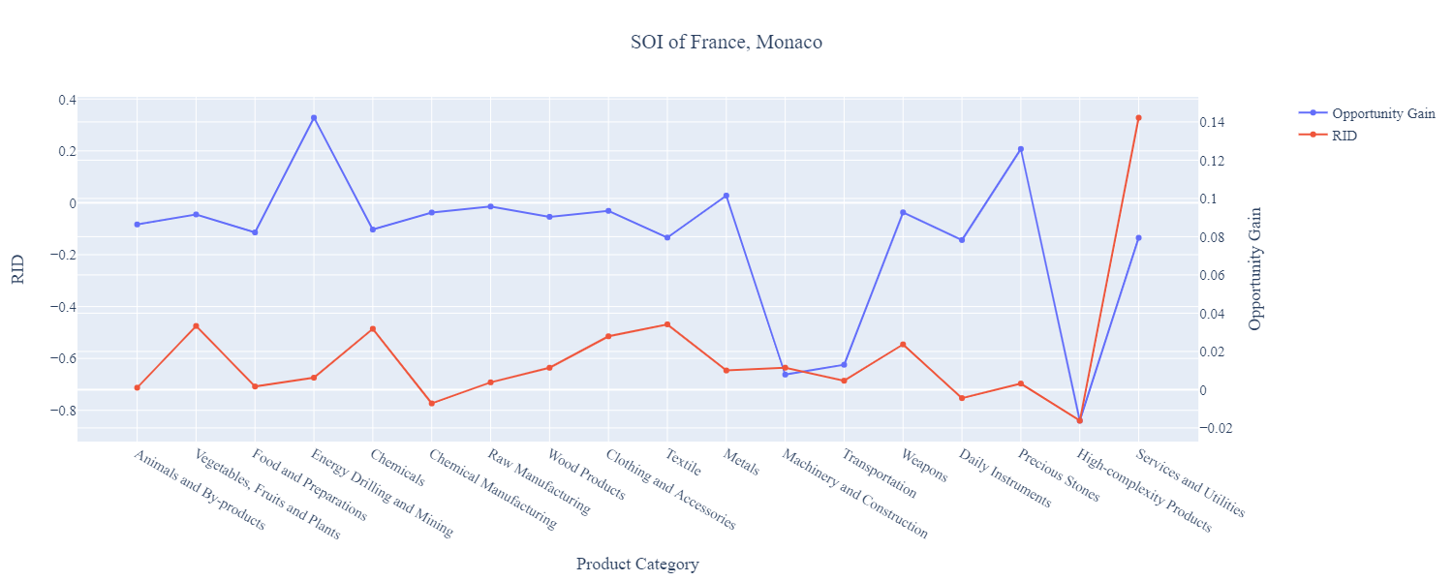

Figure 7: SOI of France (2013-2018)

For the 2019-2021 years, France has a strong presence in the Energy Drilling and Mining and Precious Stones industries, which helped France improve its growth as those are high-complexity industries. It also could consider Transportation and Machinery and Construction to improve its growth. France has seen a growth in GDP over those three years of 7.64%, with an average growth of 3.75%, compared to 0.8% for the average yearly growth for the five years prior.

Higher than before, its adjusted R-squared value of 7.6% now indicates a high correlation between GDP growth and the implemented development path. Progress is slow on a global scale during this period, but France demonstrates a greater ability to adjust to negative economic shocks by improving SOI and increasing GDP growth than it did between 2013 and 2018.

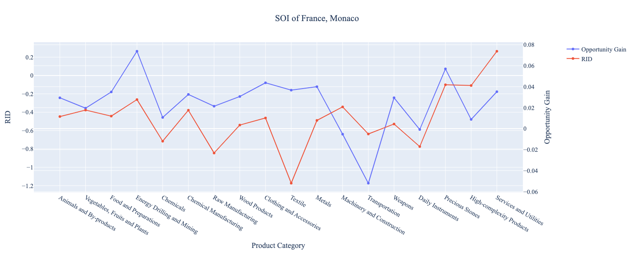
Figure 10b. SOI of France (2019-2021)

6. Concluding Remarks

In conclusion, France has demonstrated a low level of economic growth in terms of annual GDP increase during the period from 2013 to 2018, concurrent with an increase in economic complexity as compared with other major developed economies. For 2019-2021, the growth in GDP has increased alongside a sharp decline in ECI, in line with its comparable countries and higher than some of the leading economies in the world.

The lack of progress during the first period, we believe, can be partially explained through the analysis of the economic and product complexity structure of France on the industry group level. The product classification system we adopt allows us to measure the realized industry development for various industry groups and to observe that France regressed in developing most of its industries during the period, while its developed counterparts and emerging economies around the globe adopted much more complex and progressive paths.

Based on our analysis of the opportunity gain and a sensitivity analysis of major industry groups, France can further its gains by prioritizing Machinery and Construction, and Services and Utilities. We further note that France has a slightly mismatched development strategy that indicates a moderate level of structural optimality on the complexity level, having an adjusted R-square of around 4.1%. Since a significant positive correlation exists between five-year GDP growth and the structural optimality index of an economy as we define and calculate, France indeed has a suboptimal growth experience as compared with fast-growing economies both on a regional scale and on a global scale, and has the potential to further its economic gains through industrial structure optimization as suggested in the paper.

During the second examined period from 2019 to 2021, France performed much better than before but was still roughly similar compared to other countries. France was consistently outperformed by the United States in particular out of all the developed countries. We infer that during the COVID-19 period, France focused on developing higher complexity industries despite a lower demand for these industries given the global economic downturn and decreased production capacities. We also note that France has increased its investment in the sectors identified earlier, leading to a strong boost from High-complexity Products, leaving some room for strategic improvement. The ECI suggests that greater growth could have been achieved through High-complexity Products, followed by Transportation and Daily Instruments. The surprising growth also increased the adjusted R-squared value to 7.6% in 2021 from 4.1% in 2018, demonstrating the pursued strategies contributed to the GDP. With the revised focus, France has further potential to advance its economic growth to maintain its position among other countries to continue its post-pandemic recovery and ongoing economic expansion.

References

Hausmann, R., Hidalgo, C., Bustos, S., Coscia, M., Chung, S., Jimenez, J., Simoes, A. and Yıldırım, M. (2007). The Atlas of Economic Complexity. [online] Atlas.cid.harvard.edu. Available at: http://atlas.cid.harvard.edu/.

Balassa, B., “The Purchasing Power Parity Doctrine - A Reapprais- al,” Journal of Political Economy 72, 584-596 (1964).

Feenstra, R.; Lipsey, R.; Deng, H.; Ma, A. & Mo, H. “World Trade Flows: 1962-2000” NBER working paper 11040. National Bureau of Economic Research, Cambridge MA (2005).

United Nations Commodity Trade Statistics Database (http://comtrade.un.org/db/), accessed in August 2019.

The World Economic Forum, “The global competitiveness report,” (various years).

Barro, R. & Lee, J-W. “A New Data Set of Educational Attainment in the World, 1950-2010,” NBER Working Paper No. 1590 (2010).

Kaufmann, D. & Kraay, A. “Governance Indicators: Where Are We, Where Should We Be Going?” Policy Research Working Paper 4370. Washington, DC: World Bank (2008).

Hanushek, E.A. & Woessmann, L. “The Role of Cognitive Skills in Economic Development,” Journal of Economic Literature 46(3), 607- 668 (2008).

